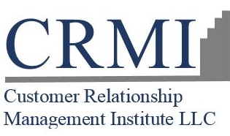  “Exceeding Customer Expectations – One Experience at a Time ℠ “  Does your company’s DNA include world class customer service by consistently exceeding customer expectations???  At CRMI, we believe that maximizing customer satisfaction and loyalty is the top priority for any company. There is nothing more important to sustainable business growth – especially in today’s competitive economy.  CRMI’s CXDNA Playbook Strategy is a step-by-step model for “continuously exceeding customer expectations” – that should be part of every company’s corporate DNA. This unique well established (1994) 12 component strategy is designed for flexible implementation to compliment your existing CX strategy or as the master blueprint of your CX strategy.  CX Stakeholders Communications services provides a professional and consistent CX communications vehicle that combines creativity with technological innovation to customize your CX strategy messages to your both external and internal stakeholders.  Use your CX Stakeholder Communication program to acquire-retain-grow and win back customers.  For more information contact:  Diane Rivera  (978) 710-3269  drivera@crmirewards.com  Customer Relationship Management Institute LLC  P.O. Box 323  Chelmsford, MA 01824-0323  Phone: (978) 710-3278  Fax: (978) 710-3381  www.crmirewards.com | CX Stakeholder Communications Program  Capitalize on your most valuable asset !excellence in customer service!
Our cutting-edge CX Communications package complements your existing corporate communications program

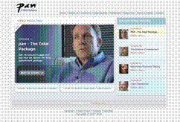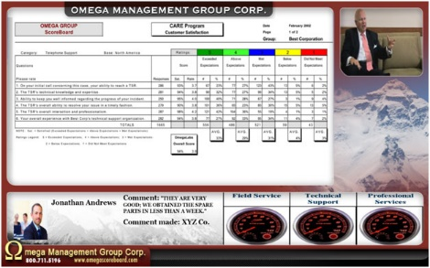
State of the Union (SOU) video -- showcase your commitment to customer service using the power of video. Perfect for web posting, |  | Feedback Information Systems feature dynamic multi-media LED dashboards that can include customer comments, survey results, videos, employee recognition, etc.
CX Annual Report has the impact of a public company annual report but focuses on your CX strategy and results. | Case Studies about your customers are living proof of the success of your CX Playbook strategy and goals. |  | Customer Events like user group meetings and sales kick-offs should not be boring! Deliver your key messages with powerful, creative and entertaining impact.

CX Stakeholder Communication Program
- Fully customizable to your company and industry -
Basic program components include:
- Annual “Voice of the Customer” Video
- Annual Customer Experience Report
- Annual Case Study
- Annual CX Communications Webcast
Optional components:
- Annual State of the Union
- Feedback Information System (lobby, cafeteria, training/demo center, conference rooms, etc.)
- Public Relations CX Campaigns
- Customer Events
- Social Media/Online Communities
- NorthFace ScoreBoard Award Media Advertisement Program
- WinBack Strategy
- CX Website Content

