CXDNA Playbook Partner Program℠  Add Value to Your Services  Groundbreaking Customer Satisfaction Award  Marks 20th Anniversary  NorthFace ScoreBoard Award℠ Established Defining SBI Metrics for  Creating World-Class Excellence in Customer Service and Support |  |  |  |  |  |  |  |  | 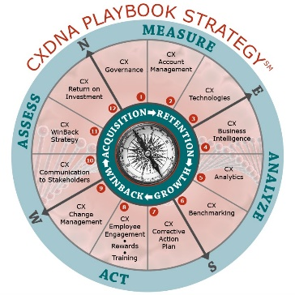
In 1984, IBM’s annual report was dedicated to the “Year of the Customer,” the first recognition that superior customer service/support (CX) is the company’s true competitive differentiator. Over the years, IBM would be joined by many other service thought leaders: Lexus, Ritz-Carlton, Walt Disney, L.L. Bean, Nordstrom, et. al. who made the transition making customer service/support their strongest and most critical competitive advantage. This vision was counter to George Orwell’s dystopian novel “1984” that imagined a society where individualism and independent thinking were regarded as "thoughtcrimes" instead of “thought leadership.” This turnaround towards service thought leadership would continue powered by CXDNA Playbook Strategy and validated by an award that was the first (2000) to recognize organizations that consistently exceeded customer expectations for service/support and that CX is the most critical component of a company’s DNA, (CXDNA).

That award –NorthFace ScoreBoard AwardSM — marks its 20th anniversary in 2020.

 |  |  | 5 |  | Reasons to Add Value
1 | Create CXDNA Standard for Service Excellence
The CXDNA Playbook Strategy and the NorthFace ScoreBoard (NFSB) Award (CXDNA) created the structure necessary to objectively measure and validate the quality of the customer experience in all interactions with a company. Before the CXDNA, measuring customer satisfaction was largely an ad hoc, reactive activity performed periodically by organizations.
But CXDNA changed the subjectivity and marginal importance of the customer experience. Since 2000, the NFSB award has been presented annually to organizations that, based solely on survey responses from a company’s own customers, consistently exceeded customer expectations for service/support for a full calendar year.

2 |  | Create Competitive Advantage
NFSB Award Delivers a Clear Competitive Edge for Recipients
The business world has come to understand that customers – not products and services – are the source of all revenue and profits. This means that companies cannot afford to turn a blind eye to CX and just rely on product features and benefits, which had been the standard before the NFSB Award helped in the transition to CXDNA culture.

Since the NFSB Award criteria is unique in both measurement metrics (SBI rating or equivalent rating system) and that only customer survey responses are used to determine the level of CX excellence a company provides, the NFSB Award is the ultimate VoC measurement.

Market Research has shown that most decision makers value an independent award recognition for outstanding customer service (JD Power – Stevie – NFSB – TSIA – ICMI – CallCenter Week – CXPA – etc.) to help drive their brand recognition. Now, as part of the CXDNA Playbook Partner program, the NFSB award will provide this unique added value recognition opportunity to your customers from a recognized CX industry independent third party.

3 |  | Provide Universal Survey Measurement – Customer Bill of Rights Guideline
The NFSB Award was innovative in establishing universal survey measurement standards’ (SBI – 1994) that use a five-point weighted average scale to measure both customer satisfaction and customer loyalty by using Level 1 as the lowest rating and level 5 as the highest rating.

The weighted average formula, referred as the ScoreBoard Index (SBI), provided a much more accurate measurement of customer sentiment (clear customer intelligence) than the traditional percent satisfied /loyal metrics. For the first time, the service executive could clearly see customer metrics that directed priorities for critical corrective action and which overtime could be re-measured to see the impact of the corrective action taken. The five-point scale made survey responses more accurate/ easy to understand and the weighted average calculation resulted in any ratings below 4.0 as simply not good enough to retain / grow customers, rather, over time would lead to customers defections. The NFSB Award five-point criteria was extended to include other rating scales (such as 3-6-7-8-9-10 point / Net Promoter Score NPS).

Example: SBI Formula (based on weighted average): Assumption: satisfaction and recommend responses were identical

Please rate your overall satisfaction with our customer service? |  |  |  |  |  | Please rate your overall willingness to recommend our customer service?
Failed all customer expectations  Perform below customer expectations  Met customer expectations  Perform above customer expectations  Exceeded all customer expectations |  |  | (1)  (2)  (3)  (4)  (5) |  |  | Definitely not recommend  Highly unlikely to recommend  Maybe recommend  Highly likely to recommend  Definitely would recommend |  |  | (1)  (2)  (3)  (4)  (5)
 |  | Value |  |  |  |  |  | Value
Level 5 (18 responses) | x | 5 points |  | = | Subtotal A / 90 | Level 5 (18 responses) | x | 5 points |  | = | Subtotal A / 90
Level 4 (14 responses) | x | 4 points |  | = | Subtotal B / 64 | Level 4 (14 responses) | x | 4 points |  | = | Subtotal B / 64
Level 3 (3 responses) | x | 3 points |  | = | Subtotal C / 9 | Level 3 (3 responses) | x | 3 points |  | = | Subtotal C / 9
Level 2 (3 responses) | x | 2 points |  | = | Subtotal D / 6 | Level 2 (3 responses) | x | 2 points |  | = | Subtotal D / 6
Level 1 (2 responses) | x | 1 point |  | = | Subtotal E / 2 | Level 1 (2 response) | x | 1 point |  | = | Subtotal E / 2
Total (40) responses divided by |  | Total point value |  |  | (171)= 4.28 SBI | Total (40) responses divided by |  | Total point value |  |  | (171) = 4.28 SBI

NFSB Award Customer Bill of Rights Guideline
Established - 1994
Article I:  Companies agree to provide goods and services that will consistently exceed their customer’s expectations.  Article II:  Companies agree to provide their employees a workplace where employees are motivated, trained and skilled, customers are valued, and relationships are maximized.  Article III:  Companies agree to recognize and reward their employees who consistently exceed their customer’s expectations.  Article IV:  Companies agree to consistently measure the level of customer satisfaction with a company’s product and services.  Article V:  Companies agree to consistently report levels of customer satisfaction for products and services to executive management and the enterprise. | Article VI:  Companies agree to adopt change management strategy to consistently provide corrective action to poor performance in products and services.  Article VII:  Companies agree to consistently measure their performance versus industry standards and/or best in class company performers.  Article VIII:  Companies agree to consistently validate their customer satisfaction results via being recipients of industry awards-certifications and/or independent audit of their customer satisfaction results.  Article IX:  Companies agree to a chief customer advocate position, reporting to the President whose sole responsibility is the ombudsmen for customers, and who consistently reports the level of customer satisfaction on product and services and provides the corrective action plan to the executive management team.  Article X:  Companies agree to annual review of their customer experience management strategy (CX) which must include Article I thru Article IX.

4 |  | Provide Independent 3rd Party CX Recognition | CXDNA Advocate Certification
Be a value-added provider of CX recognition through industry independent 3rd party certifications/award. Offer your clients opportunity to become a recipient of NorthFace ScoreBoard (NFSB) Award for customer service excellence and provide CX Advocate certification that includes aligning your CX products/services with the 12 critical component practices within the CXDNA Playbook Strategy.
Cobrand: |  |  |  | 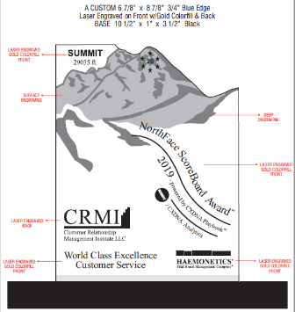 |  |  | Align: | 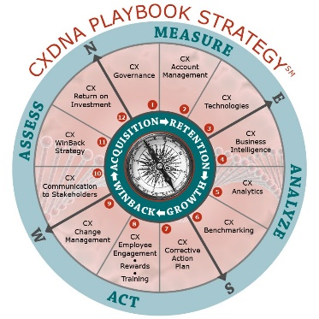
Have your clients join world class service providers such as:
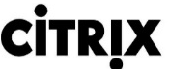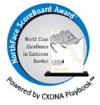
5 |  | CXDNA Playbook Strategy℠ - Trusted CX Advisor Partners
The CXDNA Playbook practices (12) along with your products/services will result in the “trusted advisor partnership” that all CX decision makers value when choosing a CX vendor.

Our revolutionary CXDNA Playbook Strategy (launched in 1994) offers a roadmap of practices to maximize the value of your products/services to your clients. CXDNA strategy makes it possible, for the first time, to establish a CX culture as a business strategy that is equal to sales, marketing and all other traditional operating areas. The CXDNA Playbook provides the knowledge and strategy to create a customer-centric culture that begins with an overall CX governance through employee engagement that will raise the awareness of, commitment to and operational practices in, continuously delivering superior customer experiences.

Playbook: Phases (4) with Component Practices (3) per phase
- Measure: CX Governance, CX Account Management, CX Technologies
- Analyze: CX Business Intelligence, CX Analytics, CX Benchmarking
- Act: CX Corrective Action, CX Employee Engagement, CX Change Management
- Assess: CX Stakeholders Communications, CX Win-back Strategy CX Return on Investment (ROI)

Your organizations applicable CX practices will be included in our CXDNA Playbook Strategy and your NFSB Co-brand award will display powered by CXDNA Playbook, your logo/your CXDNA practice to all your NFSB recipients.

CXDNA Playbook Partnership will transitions your organization
from CX Vendor to trusted CX Advisor
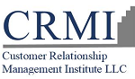  Exceeding Customer Expectations - One Experience at a Time℠ |  |  |  |  |  | CRMI is your Customer Experience Management (CEM) partner. Empower your organization with the knowledge - training - technology for delivering the ultimate customer experience. Build loyalty, drive revenue and maximize your customer’s satisfaction with a proven CXDNA Playbook Strategy.  Ph: 978-710-3278 | Email: drivera@crmirewards.com | Website: www.crmirewards.com

